Measures of Location: First Moment

[John S Butler (TU Dublin)](https://johnsbutler.netlify.com)

# Introduction

Different aspects of a distribution of data can be summarised by the measures of location:

1. The First Moment: Middle.
2. The Second Moment: Spread.
3. The Third Moment: Symmetry.

All that being said, I would always recommend plotting the data first before anything else.

**A picture (histogram) is worth a thousand words.**

# First Moment: Middle

## Mean (average)

### Definition:

The mean $\overline{x}$, $μ$ is the point around which the sum of the deviations is 0. The formula is given by

$$\overline{x}=\frac{\sum_{i=1}^{n}{x_{i}}}{n}$$

where $x_{i}$ is each element and $n$ is the number of elements. In words, add the numbers together and divided by how many numbers are in the list.

### Example

Given the list of 7 ages at a concert {19,18,20,18,18,18,20}, the mean is:

$$\overline{x}=\frac{20+18+19+18+18+18+20}{7}=18.71429.$$

In R code:

Age=c(20, 18,19, 18,18,18,20) # List of 7 numbers  
## Cacluate the mean in the long form  
(20+18+19+18+18+18+19+20)/7

## [1] 21.42857

## Cacluate the mean using the function mean  
mean(Age) # The mean of the list

## [1] 18.71429

### Graphical representation of the mean:

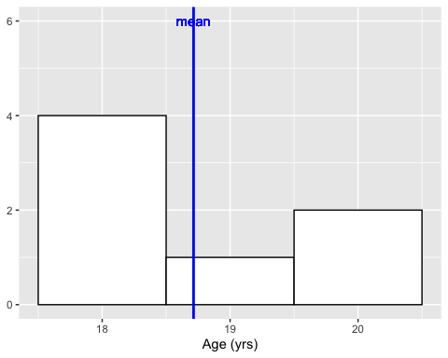

### Mean Pros and Cons

Pros of the mean:

* The mean is easy to calculate.
* The mean is well known and understood.

Cons of the mean: * The mean is senstitive to extreme values.

Given the list of the ages of 8 people at a concert {20,18,19, 18,56, 18,18,20}, the mean is:

$$\overline{x}=\frac{20+18+19+18+18+56+18+20}{8}=23.375.$$

In R code:

Age=c(20,18,19, 18,56, 18,18,20) # List of 8 ages  
## Cacluate the mean using the function mean  
mean(Age) # The mean of the list

## [1] 23.375

df <- data.frame(Age)

## Median

### Definition:

The median is the middle values of an ordered list.

### Example

Given the list of 7 ages at a concert {19,18,20,18,18,18,20}.

1. First the list has to be ordered {18,18,18,18,19,20,20}.
2. Then the middle of the list found {18,18,18,*18*,19,20,20}.

The median is 18.

In R code:

Age=c(20,18,19,18,18,18,20) # List of 7 numbers  
  
median(Age)

## [1] 18

### Graphical representation of the median:

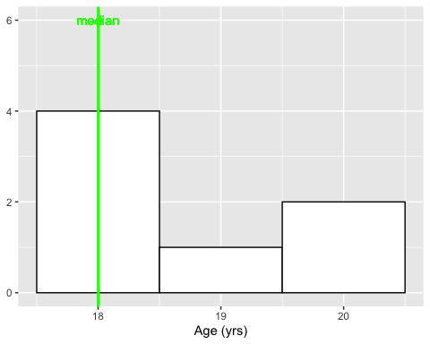 ### Median Pros and Cons Pros of the median:

* The median is the centre of the data - very intuitive.
* Not as sensitive as the mean to extreme values.

Cons of median: * The calculation of the median does not use all data. * Sorting a long list can be computationally expensive.

## Mode

### Definition:

The mode is the most commonly occurring value in the distribution.

### Example

Given the list of 7 ages at a concert {19,18,20,18,18,18,20}. The most frequent values is 18, so 18 in the mode.

### In R code:

Age=c(20,18,19,18,18,18,20) # List of 7 numbers  
# Function to calculate mode  
Mode <- function(x) {  
 ux <- unique(x)  
 ux[which.max(tabulate(match(x, ux)))]  
}  
Mode(Age)

## [1] 18

### Graphical representation of the mode:

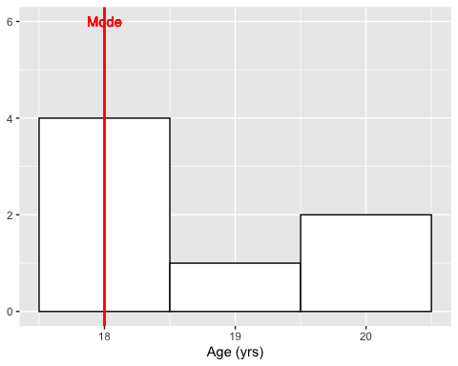

### Median Pros and Cons

Pros of the mode:

* The mode shows where the data is concentrated.

Cons of the mode:

* More than one Mode in a dataset.
* The calculation of the mode does not use all the data.

## All in one plot

Plotting a histogram of Heights from the Pearson dataset

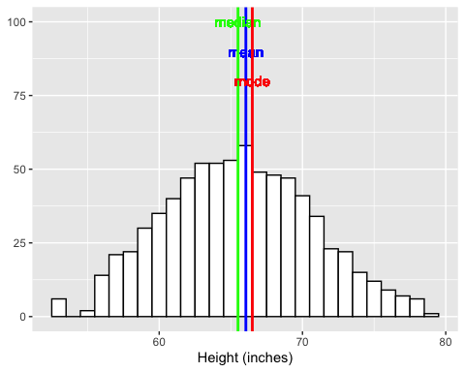

The figure below shows a histogram of 3000 attendees age observations at a Wiggles concert: 